How to Set Charging and Discharging Period
Author: Eason
Hybrid INV
Issue introduction
I don’t know how to set the charge and discharge time periods, or the meanings of the related settings.
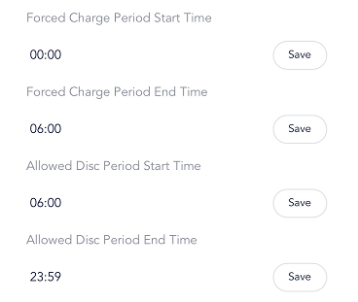
Operation guidance
Step1: Go to <User settings> to set the parameters for each work mode and set charging and discharging period.
Setting path： Setting→Password(0000)→User settings
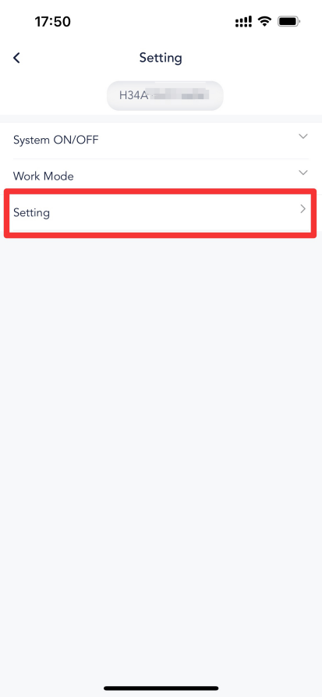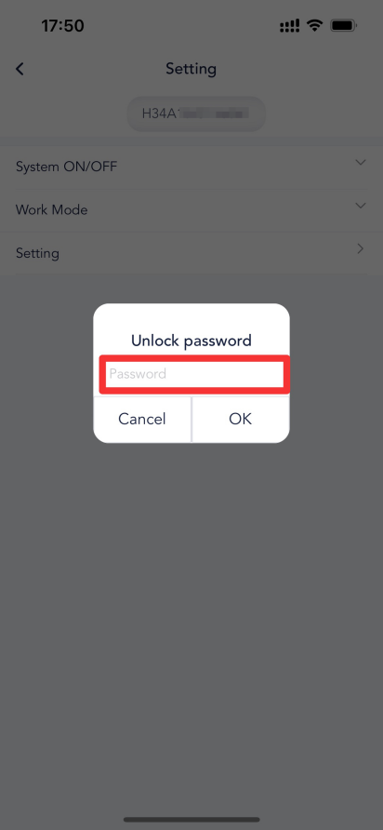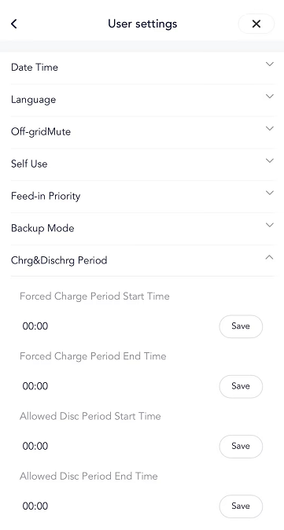
Step2: Example of selfuse operating mode,understand the settings such as Min SOC.
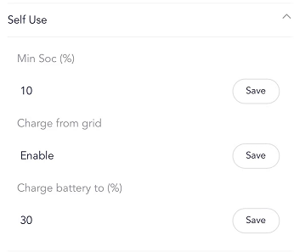
Min Soc (setable range 10%~100%): When the battery discharges to the set minimum SOC value, it will stop discharging, and the inverter will enter idle mode, halting operation. It will remain in this state until surplus PV energy is available to charge the battery, or until the scheduled boost charging time period begins, at which point it will charge the battery using grid power.
Charge from grid(enable/disable): It depends on whether you are willing to buy electricity from the grid to charge the battery.When you enable the "Charge from Grid" feature, you can configure the “Charge Battery to” setting. This determines the maximum state of charge you want to allow the battery to reach when charging from the grid.The setting in the above diagram indicates that during the charging process, the battery will charge from the grid at full power until the SOC reaches 30%. Once it reaches 30%, the battery will wait for surplus PV energy to charge the battery until it is fully charged.
Step3: For the <Chrg&Dischrg Period> setting,The battery will only discharge during the allowed discharge time period. If the time settings for parts 1 and 2 overlap, the charging time of part 1 will take priority and be executed first.
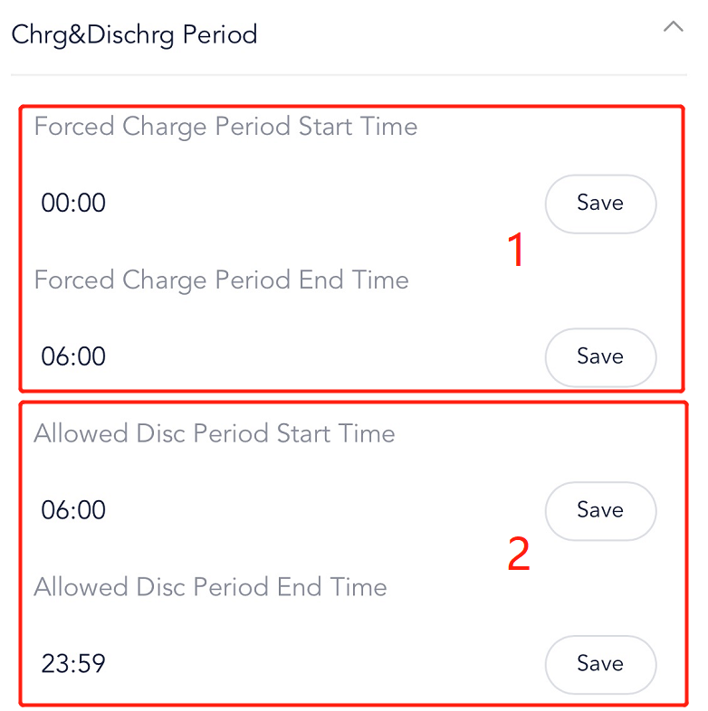
In the forced charge period, when the battery SOC is lower than the value set in **<Charge battery to %>** mentioned in step 2, both PV and grid power will prioritize charging the battery. However, when the SOC is higher than this value, the battery will not discharge, even if PV energy is insufficient to power the load.
In the allowed discharge period,both the battery and PV will supply power to the load, with PV being prioritized. Once the battery discharges to the value set in **<Min SOC>**, the inverter will enter idle mode.
Please note
- If the settings save fails, please check your mobile network, ensure a stable connection, log out of your account, and then log back in. Follow the steps above to make the changes.

